From Email from Fred Vetterlein to PMAC Leadership Team (Dec. 18, 2022)

Tuesday, Dec 13, Mildred Haley Building 2 BPDA meeting.
Project Notification Form, https://bpda.app.box.com/s/bltuu986zdibcocsxfh5fk4hswzbmelr,
The meeting was online and there weren’t many attendees other than the advisory group members, myself and some prospective residents. I asked about the SWCP path and the fact that the report didn’t address issues we sited in our Phase One Report about line striping, lighting, safety, fencing, construction, and some design element that reflected the paths benefit and function uniting the South End, Roxbury, and Jamaica Plain.
I was answered by Teronda Ellis, JPNDC Chief Operating Officer, who said that landscape work was an ongoing part of the plan, and that DCR had been contacted about the project.
The architect, Mark Eclipse, of PCA, said that they had shaped a chamfer on the front corner of the building to soften the building edge to the SWCP path. He also said that the Mildred Haley paths were designed to flow into the SWCP path and DCR needed to redesign SWCP Paths. He had a drawing of the paths around building 2 which we will have to ask him for.
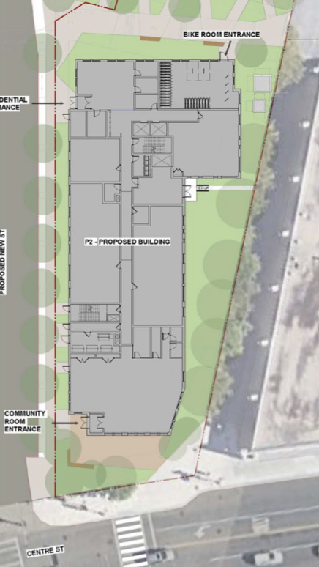 | 